<https://www.notion.so/Introduction-to-SQL-73a9d4b4d14f42c28d98924d4c8664b0>

这个是给的简单的例子教学

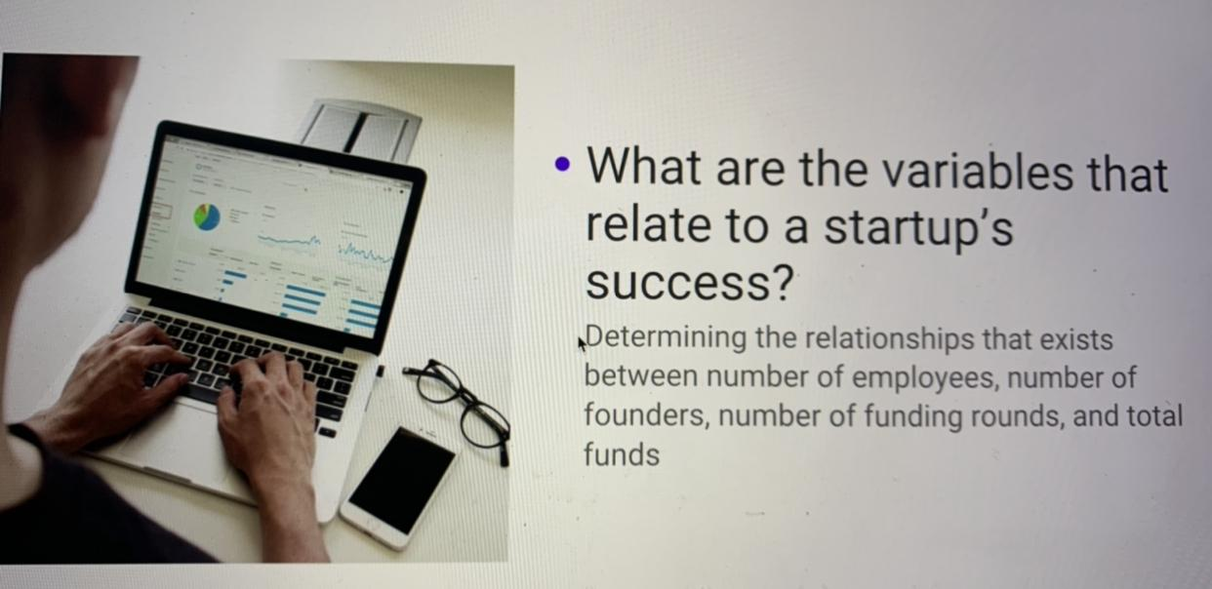

这个图片是主要问题

**下面是描述**

***Step 4:*** Before you visualize data, it can be very useful to group data and organize it in a way that is conducive for visualization and for overall inspection of the variables at a glance. You can do this using SQL and building queries to get specific information from a large dataset. Take our introductory module on SQL below.

The objective of this step is to explore questions and extract information from the dataset that is able to tell you something about questions regarding factors related to startup success that you’re curious about . Let's take an example; You could be curious to know the number of funding rounds by industry. If you were to find this information manually in your given dataset, that would take you a lot of time. Instead, you can use SQL to build a query that can return the number of funding rounds for each of the industries in the dataset.

Similarly, you can build queries to get any information you're curious about or that would help back up some of the work you're already doing; like all the startups with total funding exceeding 100 million, the relationships between revenue and funding, the total funding that seed stage companies were able to get, the list is endless!

**Paste the SQL query you used to extract and organize information from your dataset.**

**感觉到最后就是把多余的variable删一下，留下number of employees, number of funding rounds, number of founders 还有dependent variable （Total Funding Amount Currency (in USD)**